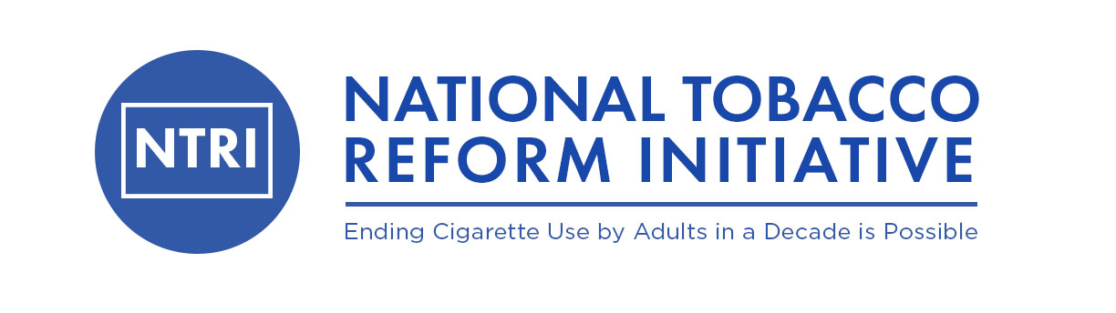

March 6, 2020

Mitch Zeller, Director

Center for Tobacco Products Food and Drug Administration 10903 New Hampshire Avenue Silver Spring, Maryland 20993-0002

**RE: Petition of the National Tobacco Reform Initiative**

Dear Mr. Zeller,

The National Tobacco Reform Initiative (hereafter referred to as the NTRI) is an informal organization led by a small group of distinguished, seasoned and independent tobacco control leaders with decades of service fighting the tobacco epidemic. NTRI is a voluntary organization and receives no financial assistance from any organization or outside entities. We advocate for civil engagement with all interested stakeholders and for open evidenced based discussions about the most effective ways to accelerate a reduction in the current number of adult smokers and associated diseases and premature deaths caused by smoking. One of NTRIs major priority areas is to establish a more rational tobacco and nicotine products regulatory framework based on their relative risks and that is adaptable to the increased speed of innovation in new technology of products that have the potential to displace deadly and addictive combustible tobacco products.

Towards this end, NTRI hereby submits this citizens petition to the United States Food and Drug Administration (FDA) and specifically the Center for Tobacco Products (CTP) to follow through on its previously asserted science-based comprehensive nicotine focused tobacco product regulatory strategy. This strategy as outlined by the FDA/CTP in 2017 recognized that there is a continuum of risk across different nicotine delivery products and suggested that public health could be markedly improved by reducing the addictiveness of combustible tobacco products while at the same time increasing access to less harmful tobacco and nicotine products (i.e., both consumer and medicinal nicotine products). The guiding principle behind the strategy was finding ways to reduce the diseases and premature deaths caused by tobacco products, the vast majority of which are currently the result of addiction to conventional, combustible tobacco cigarettes.

This petition is intended to make recommendations to the agency for carrying out its responsibilities pursuant to provisions of the Food Drug and Cosmetic Act and specifically under the Family Smoking Prevention and Tobacco Control Act and to consider ways of modernizing how it chooses to regulate a growing number of diverse tobacco and nicotine products. Specifically, we are urging FDA/CTP to establish a more flexible and workable regulatory framework that recognizes the opportunities associated with a rapidly evolving nicotine delivery product marketplace, and to support stakeholder engagement and dialogue, which can better serve public health goals and objectives consistent with the science-based comprehensive nicotine focused tobacco product regulatory strategy the agency outlined in 2017. Going forward it is critical that product innovation and investment in new technology be encouraged and not stifled. Public health authorities today are in a unique position to be able to provide solutions for dealing with the issues of adolescent use of tobacco and nicotine, while providing people who smoke cigarettes with viable lower risk alternative products that could dramatically reduce smoking caused diseases.

In conclusion, *the undersigned certifies, that, to the best knowledge and belief of the undersigned, this petition includes all information and views on which the petition relies, and that it includes representative data and information known to the petition which are unfavorable to the petition*.

Again, NTRI appreciates the leadership you have shown on this important public health issue and look forward to your response to the ideas contained in this petition.

Sincerely,

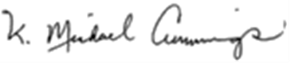

K. Michael Cummings, MPH, PhD, on behalf of the undersigned members of the National Tobacco Reform Leadership Team

David Abrams, PhD – Professor, Department of Social and Behavioral Science, College of Global Health, New York University;

Scott D. Ballin, JD – Health Policy Consultant, former Vice President and Legislative Counsel to the American Heart Association, Former Chairman of the Coalition on Smoking OR Health (ACS, AHA, ALA): Advisor to the University of Virginia “Morven Dialogues”;

Aaron Biebert- Former President and CEO, Clear Medical Solutions; Director, ‘A Billion Lives’ & ‘You Don’t Know Nicotine’

Allan C. Erickson – Former Vice President for Public Education and Tobacco Control, American Cancer Society, Former Staff Director, Latin American Coordinating Committee on Tobacco Control;

Ray Niaura,PhD -Professor School of Public Health Global Studies, New York University;

John R. Seffrin, PhD – Retired

_____________________________________________________________________________________

cc: Stephen M. Hahn MD, Commissioner U.S. Food & Drug Administration